**HOW TO ADD OR UPDATE CONTACT INFORMATION**

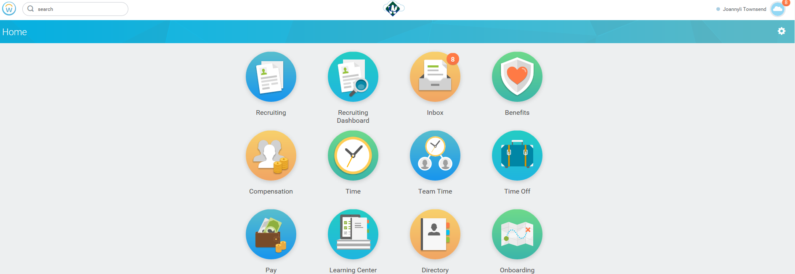

1. Log in Workday using your credentials
2. Go to Home
3. On the upper right side of the screen you will see your name, click on the cloud
4. Then choose “View profile” under your name”
5. The prior step will take you to the below screen

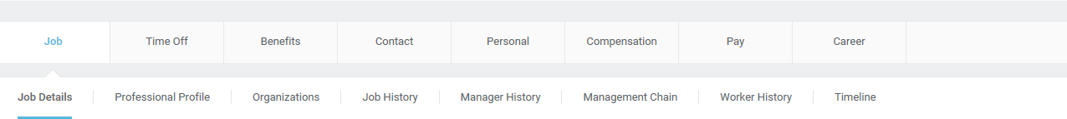

1. Using these headers you can do multiple changes to your profile as, your address, tax elections, and request time off. Also you can edit or update your personal/contact information and/or see your pay history.

* EDITING/ADDING OR UPDATING YOUR PERSONAL INFORMATION:

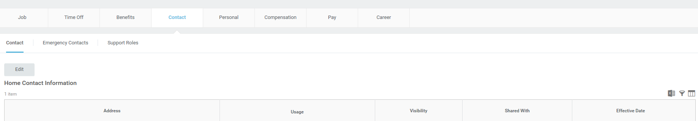

* Select Contact Edit
* Then click the pencil arrow

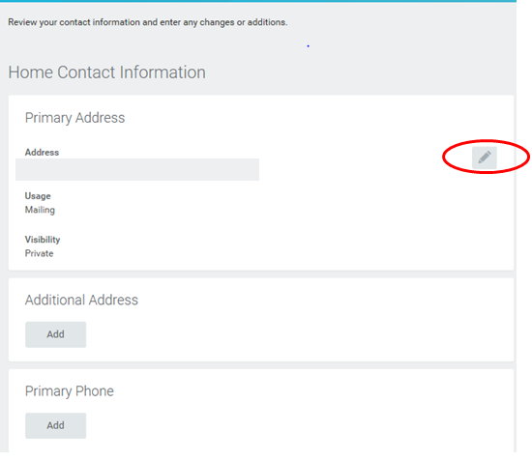

* Start updating or changing your address. You will need to select the effective date of the change, the country, city, state and postal code. Click submit to finish.

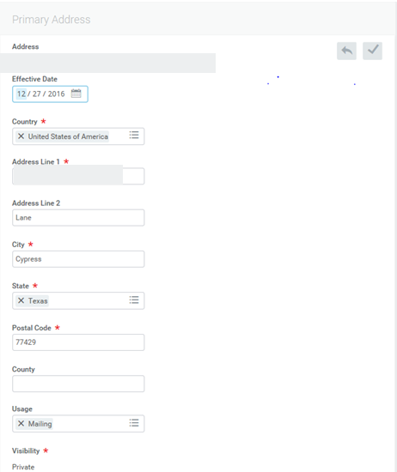 ***You can also add an additional address, your phone, emails, and attach documents you want to related to your contact information***

